 | Trainer Pool  Management  Technical Design Document  1.0
 | Prepared By / Last Updated By | Reviewed By | Approved By
Name | Sandeep Kumar Mohanty | Chhavi Sharma | Akshay Alok
Role | Team Member | Team Member | Scrum Master
Signature
Date | 04/11/2019 | 04/11/2019 | 04/11/2019

Table of Contents

1.0 Introduction 3
1.1 Purpose of this document 3
1.2 Scope 3
1.3 Intended Audience 3
1.4 Definition & Acronyms 3
2.0 Conventions and Standards Followed 4
3.0 Assumptions, Dependencies and Risks 4
3.1 Assumptions: 4
3.2 Dependencies: 4
4.0 Schematic Diagram 4
5.0 Use Case Realization 5
5.1.1 User Registration 5
a. Functional Requirement 6
b. UI Validations 6
c. UI Controls 7
d. UI Methods Definition 8
e. UI Design 9
6.0 Database Design 10
6.1 Data Model 10
6.2 Tables Structure 10
7.0 Change Log 13

Introduction

Purpose of this document
This document is aimed at:
- Providing the necessary inputs to the detailed requirements gathering phase and further on for the SDLC processes.
- This document also serves to establish the traceability between the Business Objectives and the requirements identified in the proposed solution and how they satisfy the stated objectives.
- Provide expectation traceability in terms of the requirements and the user expectation
- Serves as a formal template for documenting the Business Requirements which also includes statutory and regulatory requirements.
The purpose of this document is to systematically capture requirements for the project and the system to be developed. Functional requirements are captured in this document. It also serves as the input for the project scoping.

Scope
This sub-section shall state the scope of this detailed design document
• Create and maintain Admin information.
• Create and maintain Trainer information.
• Create and maintain SME information.
- Maintain the working of each category.

Intended Audience
The intended audience for this document are
- All members of the project.
- Delivery assurance/excellence group

Assumptions, Dependencies and Risks

Assumptions:
- Once the application is built the Trainer Pool Management will manually load the user list into the system.
- There will be no concurrent users for the application. The User profile will be maintained by the User.
- Any changes to the design mentioned in the BRD would be taken as a Change Request

Dependencies:
- Availability of database design characteristics & access shall be defined by the
- Resource availability throughout each of the sprint

Schematic Diagram
A schematic, or schematic diagram, is a representation of the elements of a system using abstract, graphic symbols rather than realistic pictures. It gives an overview of overall system

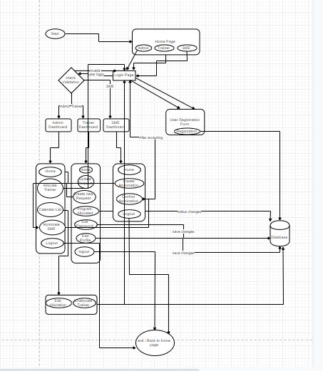

DFD for Trainer Pool Management

Use Case Realization

User Registration

Functional Requirement
Login Page checks the authentication of the user and based on his role, directs the user to the respective page. User will be provided with dashboard to select the options and the will be allowed to perform requests, nominations and other functionality.

UI Validations
- User Id and Password fields are mandatory.
- Invalid User Id and / or password should not allow the user to get into the system

UI Controls
# | UI Component | Type | Name | Details
1 | Username | Text Field | username | To enter username
2 | Password | Password | password | To enter password

UI Methods Definition
Method Name | Parameter | Details
REGISTER | None | Allows the user to register
addAllocation | Trainer t, int cid | Admin will allocate the course
delAllocation | Trainer t, int cid | Admin will deallocate the course
getAllTrainers | None | Admin will get the details of all the trainers.
getAllActiveTrainers() | None | Admin can see the all active trainers
addTrainer | Trainer t | Trainer can register itself.
deleteTrainer | Trainer t | Used for allocations functionality in the backend.
addSME | SME sme | SME’s will be added
deleteSME | int smeid | Used for allocations functionality in the backend.
getAllSMEs | None | Get the details of all the SME
getAllActiveSMEs() | None | Gets the details of all the active SMEs
updateSME | SME sme | Can update the details of the SME
updateSDates | int smeid,Date sd,Date ed | Can update the dates of the nomination

UI Design
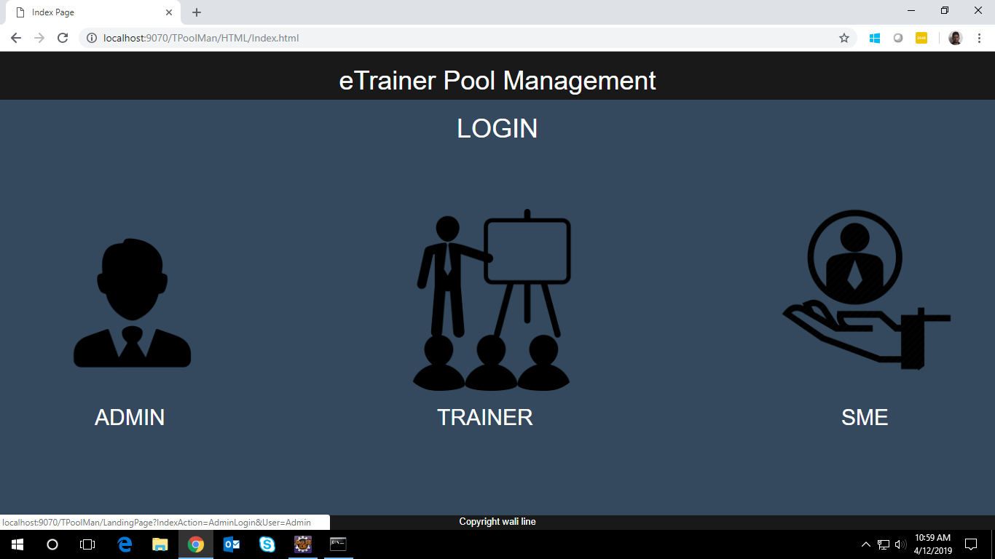

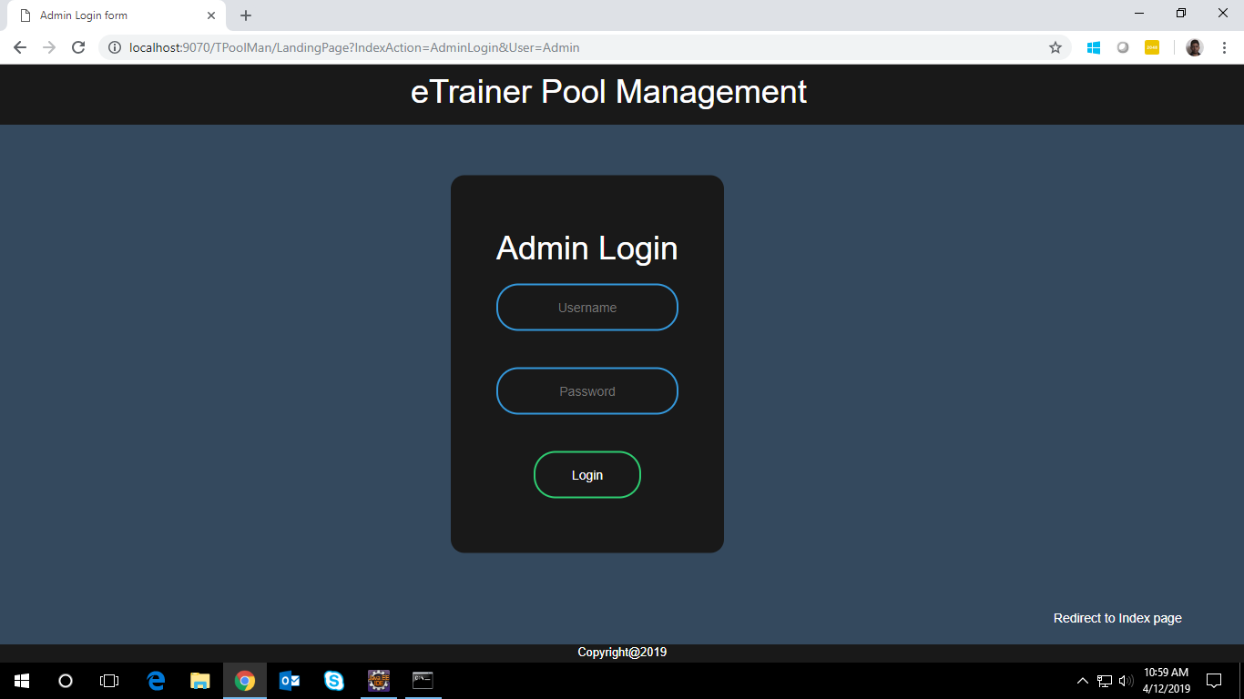

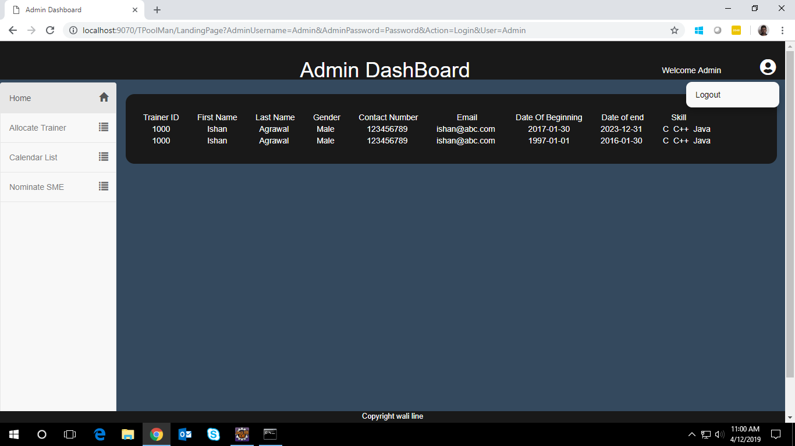

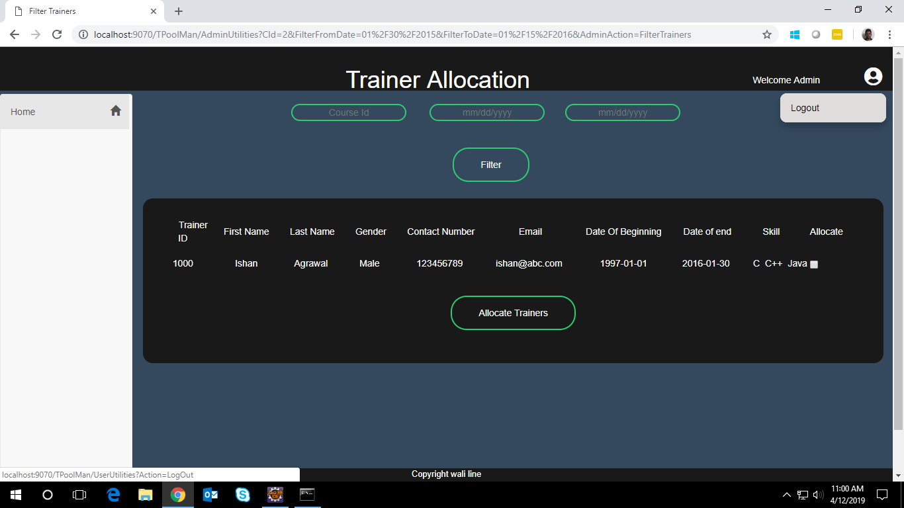

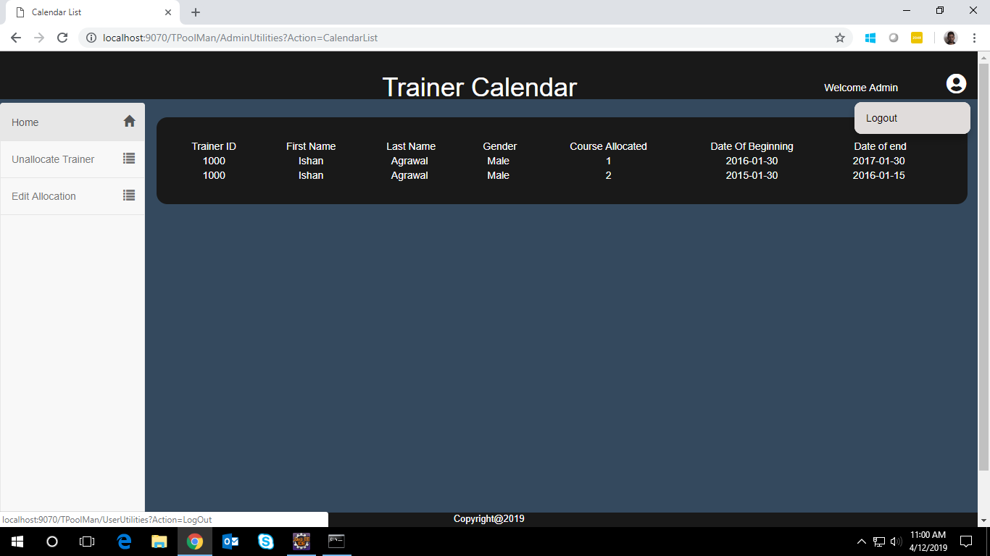

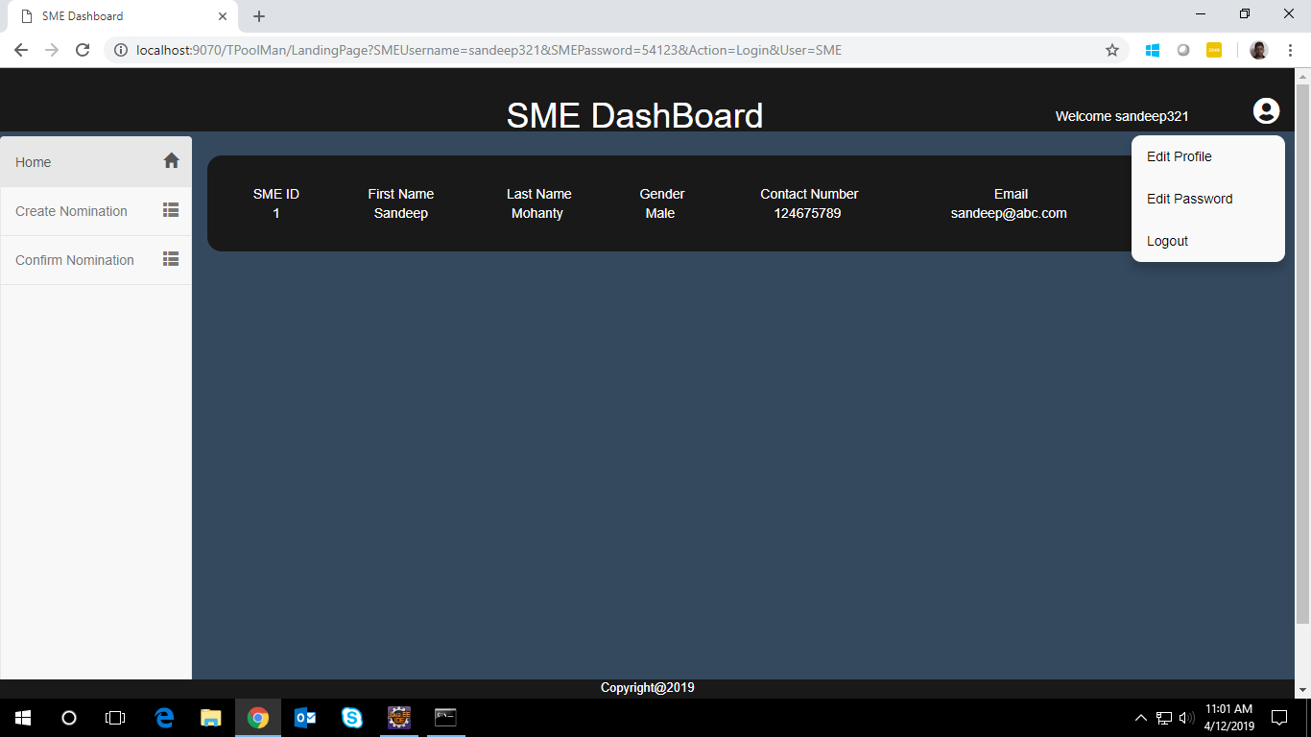

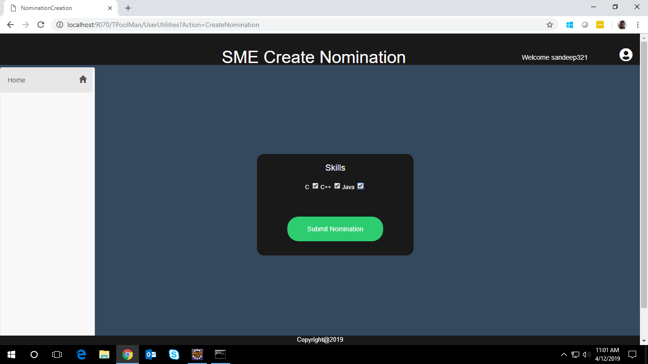

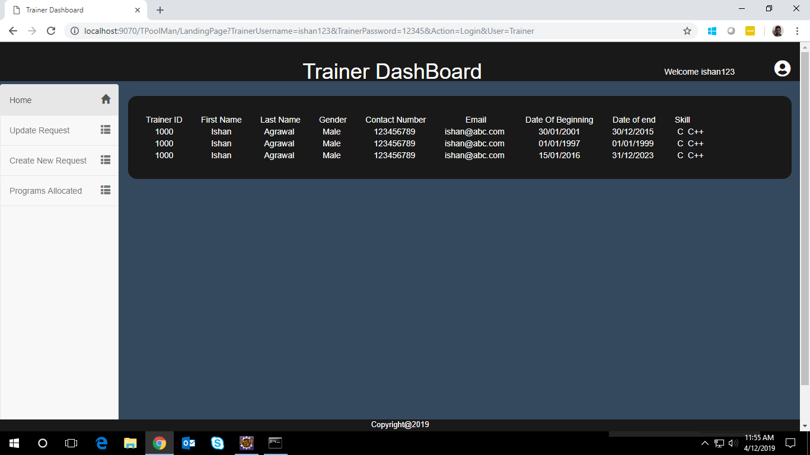

Database Design

Data Model

The following is a schematic view of the database design

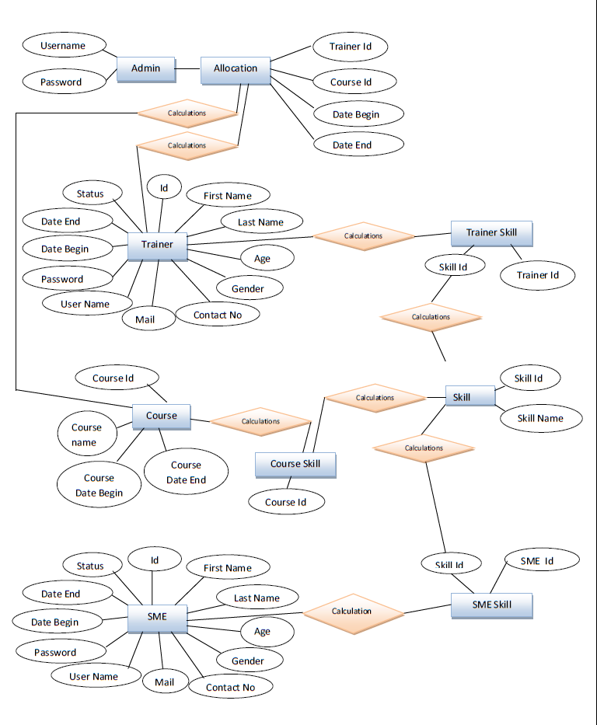

Tables Structure
Trainer Table:
Field  Name | Field Type | Data Type | Mandatory | Possible Values
First Name | varchar(50) | Alphabetic | Yes
Last Name | Text(50) | Alphabetic | Yes
Age | Numeric(2) | Numeric | Yes
Gender | Drop Down | NA |  | Male, Female
Contact Number | Text(10) | Numeric | No
UserId | Text(15) | Alphanumeric | Yes
Password | Text(15) | Alphanumeric | Yes
dateBegin | Varchar(10) | date | yes
DateEnd | Varchar(10) | Date | yes
Check | Varchar(10) | Date | yes
Admin Table:
Field  Name | Field Type | Data Type | Mandatory | Possible Values
User Name | varchar(50) | Alphabetic | Yes  (Primary key
Password | varchar(50) | Alphabetic | Yes

SME Table:
Field  Name | Field Type | Data Type | Mandatory | Possible Values
Sid | number | int | Yes
sFirstName | Varchar(20) | Alphabetic | Yes
sLastName | Varchar(20) | Alphabetic | Yes
sAge | Number | int | yes
sGender | Varchar(10) | Alphabetic | yes | Male female
sContactNo | Varchar(13) | Alphabetic | Yes
Username | Varchar(20) | Alphanumeric | Yes | unique
Password | Varchar(10) | Alphanumeric | yes
sDateEnd | Date | Date | yes
Check | Date | Int | yes

Admin login:
Column Name | Data Type | Length | Nulls
Username | varchar | 50 | N
Password | varchar | 50 | N

Trainer login:
Column Name | Data Type | Length | Nulls
Username | varchar | 50 | N
Password | varchar | 50 | N

SME login:
Column Name | Data Type | Length | Nulls
Username | varchar | 50 | N
Password | varchar | 50 | N

User Registration:
Column Name | Data Type | Length | Nulls
First Name | varchar | 10 | N
Last Name | varchar | 50 | N
Age | number | 50 | N
Gender | radio |  | N
Username | varchar | 50 | Y
Password | password | >8 | N
Confirm Password | password | Same as password | N

Change Log
Please note that this table needs to be maintained even if a Configuration Management tool is used.
Version Number | Changes made
V1.0 | <First version>
V1.1 | <If the change details are not explicitly documented in the table below, reference should be provided here>
V1.1 | Page no | Changed by | Effective date | Changes effected
V1.2 | <If the change details are not explicitly documented in the table below, reference should be provided here>
V1.2 | Page no | Changed by | Effective date | Changes effected

